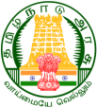

Uthamacholapuram, Salem-636 010
May – 2022 PREPARED BY: ET-Branch Vol: 5 No: 5

SPECTRUM
ECHO OF DIET SALEM
EE
Ece

Awareness of Educational Rese

The Next Generation of the Internet
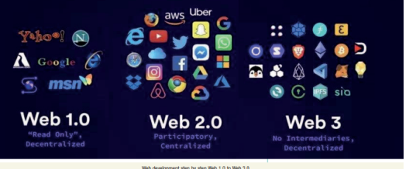
In recent times, Web 3.0 has gripped the Internet world. Web 1.0 was the start of the Internet when there were only static pages. Web 2.0 became more interactive. Tim Berners-Lee and his colleagues began developing the World Wide Web in 1989 at the CERN (Conseil Européen pour la Recherche Nucléaire) based in Geneva, Switzerland. They created a protocol, Hyper Text Transfer Protocol (HTTP), which standardized the communication between servers and clients.
Web 1.0: Read-only In 1990, the internet was a group of connected computers and the Web was the first application that Tim Berners-Lee created. Web 1.0 was designed as a ‘hyperlinked information system’. A huge library of data was sourced together from computers across the network for the users to browse the content by clicking around linked text and images. Web 1.0 was created to be used by the companies and the content used to be static (read-only) where users didn’t have an option to give feedback, comment, or quotes. The Webmaster used to be the one responsible for updating users and managing the content of the Website.
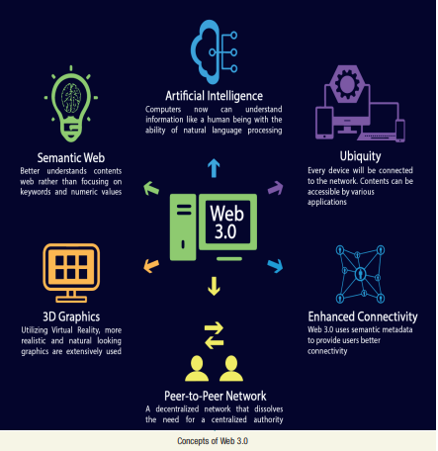
Web 2.0: Read + write After ten years, with the emergence of giant companies like Google, Facebook, and Twitter, Internet gained massive user base. Web 2.0 was created to be used by the communities. For the first time, anyone could publish content online.
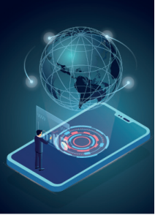
As barriers faded, users and usage surged. The Internet had something for everyone. It became more widespread as it offered user-to-user interaction, content creation, and content retrieval. In the backend, three significant shifts shaped Web 2.0 as we know it today. These are use of smart mobile phones, Social Media platforms and Cloud storage. Web 2.0: The Cons Ownership: Platforms own everything that is created online including the data provided by the users, the generated behavioral data, and the images, videos, songs, status updates and comments uploaded. Whatever we do on the platform becomes the platform’s property. The attention economy: Websites compete for users’ attention with algorithmically generated content loops that keep us scrolling and headlines that force us clicking as it has become the Internet’s naive currency. On Web 2.0, we are fed with a personalized diet of whatever triggers us the most. This leads to clickbait, misinformation, fake news, ad blockers, and ad blocker-blockers. De-platforming: Close to 90% of the Web is stored with four The Next Generation of the Internet Web development step by step Web 1.0 to Web 3.0 6 May 2022 ing providers, the biggest of which is Amazon Web Services (AWS). Their data centers run the sites and apps we use every day: Facebook, Twitter, Netflix, Uber, Reddit, and so on. We access them through Web browsers and download them from mobile App stores. These companies control the gates to the global marketplace of ideas.
Hacker Paradise: An interconnected economy that combines decentralized data creation with centralized storage giving enormous rewards to hackers. Billions of devices uploading data to a handful of massive data centres are analogous to a central bank with infinite entry points. Data breaches have become the new norm in terms of privacy and cyber-terrorism. Web 2.0’s centralized nature opens the door to security threats.
Trust problem: The Internet pioneers never meant Web 2.0 to be centralized but the core challenge of human social organization, trust, was overlooked by them. Units of civilization: Institutions foster trust among strangers by keeping track of who owns what. Taxes, payments, real estate, and exchanges records confirm the truth, and the truth builds trust.
Gatekeeper: Unbounded by space and time, today’s Internet institutions have slashed the latency and cost of economic exchanges – unlocking instant global business. They achieve this by letting the software take care of trust. We trade with strangers worldwide having enormous faith on the data provided by the Internet.
Web 3.0: Read + write + own Web 3.0 is an umbrella term for an online ecosystem that cuts out the prominent mediators on the Internet. Central gatekeepers do not own platforms on Web 3.0 and you would not navigate the internet through search engines such as Google.
It Web 3.0 Concepts: Artificial Intelligence (AI): Most people believe that AI will play a big part in Web 3.0 due to the heavy involvement of machine-to-machine communication and decision-making needed to run many Web 3.0 applications.
Metaverse: It is the user interface, through which we interact with the online world, communicate with other users and manipulate data concerning Web 3.0.
The metaverse is intended to be a much more immersive, social, and persistent version of the Internet that we are all familiar with and enjoy. It will entice us by utilizing Virtual Reality (VR) and Augmented Reality (AR), allowing us to interact with the digital domain in more natural and immersive ways. For example, we could use virtual hands to pick up and manipulate objects, and our voices to is an idea for a new iteration based on block chain technology, which incorporates concepts including decentralization and token-based economics. Web 3.0 aims to reduce dependency on large tech companies.
Why is it on everyone’s minds? Thirty years into mass Internet adoption, our data architectures are still based on the concept of standalone computers – data is centrally stored and managed on a server and sent or retrieved by a client. Every time we interact over the Internet, copies of our data get sent to the server of a service provider, and every time that happens, we lose control over our data. Our data is still centrally stored: on our computers or other devices, on the USB stick, and even in the cloud, which raises issues of trust.
Concepts of Web 3.0 May 2022 7 instruct machines or converse with others. In many ways, the metaverse can be thought of as the interface through which humans will engage with Web 3.0 tools and applications. Creating Web 3.0 applications without involving the metaverse is possible.
Bitcoin is one example, but metaverse technology and experiences are expected to play a significant role in how many of these applications interact with our lives.
Bitcoin : Bitcoin is a decentralized digital currency, without a central bank or single administrator, that can be sent from user to user on the peer-to-peer bitcoin network without the need for intermediaries.
Blockchain : Although the concepts surrounding blockchain technology is extremely complex, blockchains themselves are relatively simple. In layman’s terms, a blockchain is a public database.
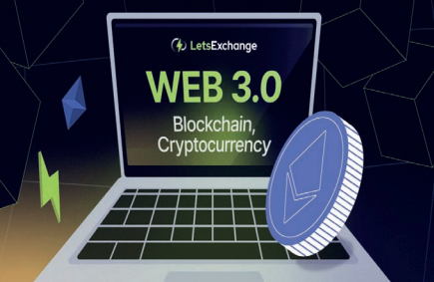
Blockchains keep a record of transactions between parties on a public forum that anyone can access. Following are the main differences between a regular database and the
Blockchain : l A blockchain is append-only: Data cannot be changed once it has been written, i.e., information is locked on the blockchain forever. l A blockchain takes the form of a linked list instead of a table: Every set of transactions (known as a block) added to the blockchain reference the previous block. As a result, there is a chronological record of every transaction that has ever occurred on the blockchain. l Blockchains are decentralized: They are not owned by any specific organization and cannot be removed in the same way that a regular database can. This is due to the fact that a single blockchain is replicated among hundreds of different users, each of whom runs a node, each of which contains an identical copy of the blockchain’s entire history. Crypto currencies are digital currencies that can be exchanged online as a payment for goods and services. It is a new kind of private digital currency or digital money, which can be used to pay someone using the Internet. It is radically different from the traditional currency to which we are accustomed. Crypto currencies are frequently managed through governance protocols, in which stakeholders vote on proposals for future token-related decisions. Crypto currencies differ from traditional digital payment methods in a variety of ways
Permissionless : Anyone in the world can access and transfer crypto currency directly without having to register on a financial platform. Users are not at risk of having their assets frozen or controlled by a third party.
l Anonymity: Governments regulate financial platforms, and as a result, personal data is required to use their services. Cryptocurrencies enable the transfer of ownership without the need for proof of identity. l
Volatility: Market value can vary wildly (except stable coins) based on expectations for the project or blockchain tech as a whole. It is difficult to predict when Web 3.0 will be fully implemented; but given that it took over ten years to transition from the original Web, Web 1.0 to Web 2.0, it is expected to take at least that long, if not longer, to fully implement and reshape the Web with Web 3.0.
Courtesy By :
ViPNet-The author is a Science Communicator, and Project Scientist under the ISTI Portal at Vigyan Prasar. Email: subodh.vigyanprasar@gmail.com
MAY- 2022-Consolidated work done:
02.5.2022 | Zonal Action Research meeting at DIET, Krishnagiri.
04.5.2022 | Zonal Action Research meeting at DIET, Dharmapuri.
05.5.2022 | Zonal Action Research meeting at DIET, Namakkal.
06.5.2022 | Zonal Action Research meeting at DIET, Uthamacholapuram.
09.5.2022 | Refresher Course on “Enhancing the Professional Skill of Deputy Directors and Principals (DIET) in Yercaud.  Fused ITK – Illam Thedi Kalvi.
10.5.2022 | Refresher Course on “Enhancing the Professional Skill of Deputy Directors and Principals (DIET) in Yercaud .  Fused ITK – Illam Thedi Kalvi.
11.5.2022 | Refresher Course on “Enhancing the Professional Skill of Deputy Directors and Principals (DIET) in Yercaud.  Fused ITK – Illam Thedi Kalvi.
12.5.2022 | Refresher Course on “Enhancing the Professional Skill of Deputy Directors and Principals (DIET) in Yercaud.  Fused ITK – Illam Thedi Kalvi.
13.5.2022 | Refresher Course on “Enhancing the Professional Skill of Deputy Directors and Principals (DIET) in Yercaud.  Fused ITK – Illam Thedi Kalvi.
16.5.2022 | Preparing report for Refresher course on Professional Development for DD’s (SCERT) and Principals (DIET.)
17.5.2022 | Selection of KRPs for “Ennum Ezhuthum” Programme.
18.5.2022 | ITK - visit.
19.5.2022 | SCERT Director’s address on Ennum Ezuthum Training, through video conference, Time 3.00 pm to 4.00pm.
20.5.2022 | கொடுஞ் செயல் எதிர்ப்பு நாள் உறுதிமொழி எண்ணும் எழுத்தும் – திட்டம் செயல் முறைகள்
21.5.2022 | எண்ணும் எழுத்மசார்ந்த மாவட்ட அளவிலான கருத்தாளர் பயிற்சி வழங்குவதற்கான இணையவழிக்கூட்டம் முதன்மைக்கல்வி அலுவலர் சார்பில் நடைபெறுதல் நேரம் மாலை 4,00 முதல் 5,00 மணி.
23.5.2022 | சேலம் மாவட்டம், நங்கவள்ளி, மேச்சேரி ஒன்றியங்களில் உள்ள 30 பள்ளிகளுக்கு நூலகப் புத்தகங்கள் ரோட்டரி மூலம் இணைந்து புத்தகம் வழங்குதல் விழா.
24.5.2022 | எண்ணும் எழுத்தும் – முன்பணி – தயாரிப்புப்பணி – மதுரை (தமிழ் பாடம்)
25.5.2022 | எண்ணும் எழுத்தும் – முன்பணி – தயாரிப்புப்பணி – மதுரை (தமிழ் பாடம்)
26.5.2022 | எண்ணும் எழுத்தும் – முன்பணி – தயாரிப்புப்பணி – மதுரை (ஆங்கிலம் பாடம்)
27.5.2022 | எண்ணும் எழுத்தும் – முன்பணி – தயாரிப்புப்பணி – மதுரை (ஆங்கிலம் பாடம்)
28.5.2022 | எண்ணும் எழுத்தும் – முன்பணி – தயாரிப்புப்பணி – மதுரை (கணிதம் பாடம்)
29.5.2022 | எண்ணும் எழுத்தும் – முன்பணி – தயாரிப்புப்பணி – மதுரை (கணிதம் பாடம்)
30.5.2022 | எண்ணும் எழுத்தும் – மாவட்ட அளவில் பயிற்சி சார்ந்த தயாரிப்புப் பணிமனை
31.5.2022 | எண்ணும் எழுத்தும் – மாவட்ட அளவில் பயிற்சி சார்ந்த தயாரிப்புப் பணிமனை

Dr M.Selvam - Principal
- Marked the importance of the series of titles which had been discussed in “Aasan Avai” on 1.5.2022; 15.5.2022; 22.5.2022 and 29.5.2022.
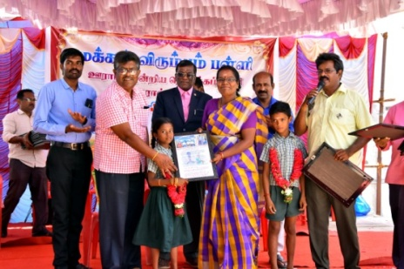
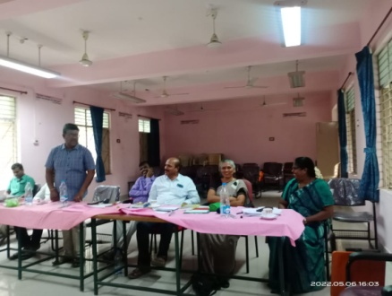
- Participated in ZARC meetings at DIET, Krishnagri, Namakkal on 5.5.2022 and DIET, Salem on 6.5.2022 respectively.
- Organized and Participated in “Refresher Course on Professional Development for Deputy Directors and Principals” at Tabor Retreat, Yercaud from 9.5.2022 to 13.5.2022.
- Visited Illam Thedi Kalvi (ITK) centre’s at PUPS, Ariyampalayam (North), Veerapandi Union on 18.5.2022.
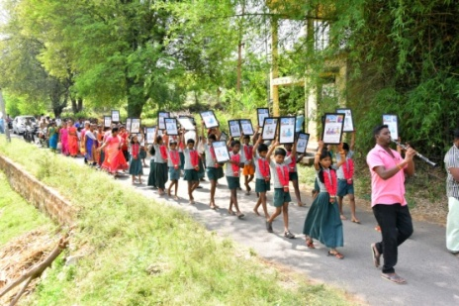
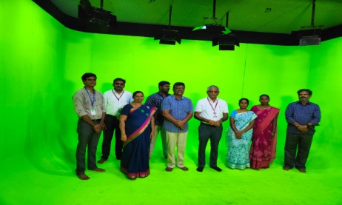
- Participated in ITK monthly meeting at mini conference hall at Collectorate, Salem at 4.00pm on 20.5.2022.
- Organized video conferencing meeting for CEO, DEO, BEO. BRC performs on Ennum Ezhuthum Training at 4.00 pm on 21.5.2022.
- Donated DIET –Rotary Books to 10 Schools of Panamarathupatty Union on 22.5.2022 ; 30 Schools of Nangavalli Union and 30 schools of Mecheri, union on23.5.2022 and 30 schools Omalur union 26.5.2022.
- Met His Excellency – Vice Chancellor Dr R. Jaganathan, Periyar University for making MOU between Library of Periyar University Salem and Library of DIET Salem on 25.5.2022.
- Organized the function on ‘’Pedagogical Enthusiast Award 2022’’ for 44 Teachers at DIET, Salem on 27.5.2022.
- Participated in the discussion on ‘Salem Peadia Project ’ at Syndicate Hall, Periyar University, Salem on 28.5.2022.
- Inaugurated the workshop on preparing at DIET, Salem on 30.5.2022.
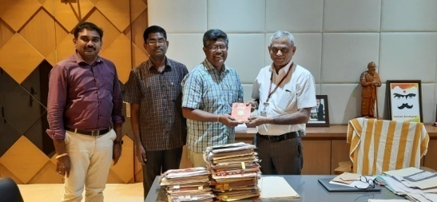

Special Event :
His Excellency Vice Chancellor Dr R. Jaganathan, Periyar University, Salem Visited DIET, Salem on 06.5.2022. He observed the Audio Recording in this Studio. He enquired about learning management system to Dr. K.Ramesh Kumar , IFIC Branch, DIET, Salem. He visited the DIET Library. Finally he participated and observed the DIET initiatives and Activities related towards Education in ZARC meeting.

PRE – SERVICE TEACHER EDUCATION: (PSTE)
Dr P. Govinda Prakash - Senior Lecturer
- 4.5.2022-Participated and Involved in meeting on Action Research proposal review in
ZARC-at DIET, Dharmapuri.
- 5.5.2022-Participated and Involved in meeting on Action Research proposal review in
ZARC-at DIET, Namakkal.
- 23.5.2022 to 25.5.2022 – Attended Capacity Building Training for DIET faculty members at Yelagiri.
- 26.5.2022-Action Research Documentation work was seen.
- 27.5.2022 - Prepared and Replied for RTI letter.

S.Selvi- Lecturer
- 2.5.2022-Prepared Content of School English Grammar –(Present Continuous Tense ) for Primary School Teachers.
- 4.5.2022-Prepared Content of School English Grammar –(Present Continuous Tense ) for Primary School Teachers.
- 6.5.2022-Prepared Content of School English Grammar –(Present Continuous Tense ) for Primary School Teachers.
- 9.5.2022 & 10.5.2022- Prepared Content of School English Grammar –(Present Continuous Tense ) for primary School Teachers.
- 11.5.2022 to 13.5.2022 – Prepared Content of School English Grammar –(Present Perfect Tense ) for primary School Teachers.
- 16.5.2022-Involved in Low Performance Learning Outcome of Hard Spots in 6thStd English Subject Video and Module Correction and restructuring work at Kanchi Hotel Chennai.
- 23.5.2022 & 24.5.2022 -Prepared Content for School English Grammar –(Present Perfect Tense ) for Primary School Teachers.
- 25.5.2022 & 26.5.2022-Attended Ennum Ezhuthum Training for District Resource persons at Pillar Hall, Madurai and Namakkal.
- 27.5.2022 -Ennum Ezhuthum TLM Preparation work at DIET was seen.
- 30.5.2022 & 31.5.2022- Ennum Ezhuthum TLM Preparation work at DIET was seen.
Dr S.PeterAnandh - Lecturer
- 2.5.2022 -Women Empowerment – Subject Correction was seen.
- 4.5.2022-Visited and Arrangements were made for Pre Planning work of Capacity Building Training for Principal’s at Yercaud Block.
- 5.5.2022-Organized a Preliminary work for Training on Capacity Building to all DIET’s Principal’s and DD’s (SCERT-Chennai) at Yercaud.
- 6.5.2022 - Learning Outcome-Pruning work was seen.
- 9.5.2022 to 14.5.2022 –Acted as a Liaison Officer in Refresher Course Training for DD’s SCERT-Chennai and all DIET Principal’s held at Yercaud.
- 16.5.2022 -Learning Outcome Planning work was seen.
- 25.5.2022 - Physical Education Module Preparation work was seen.
- 26.5.2022 to 28.5.2022 –Attended Capacity Building Training Programme at Yelagri.

R.Ravi - Lecturer
- 2.5.2022- Visited ITK centre at Jodukuli Pudur.
- 4.5.2022-History subject content preparation work was seen.
- 6.5.222-Attended discussion meeting of Vice Chancellor, Periyar University, Salem and ZARC meeting at DIET, Salem.
- 9.5.2022 to 13.5.2022 – Social Science subject Bridge Course Material Verification work was seen.
- 16.5.2022 to 20.5.2022 –Attended Social Science subject Bridge Course Material Development Workshop at Kanchi Hotel Chennai.
- 26.5.2022 to 28.5.2022-Attended “Professional Enhancing Skills” Training at O’Nila Hotel, Yelagri Hills.
- 31.5.2022 -“Ennum Ezhuthum” center visited at Kadayampatti Block.
IN-SERVICE FIELD INTRACTION INNAVATION AND CO-ORDINATION : (IFIC)
Dr K.Ramesh Kumar - Lecturer
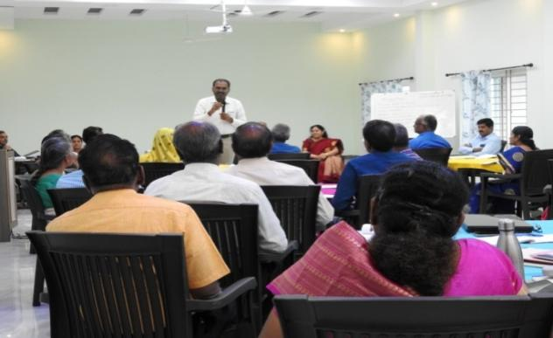
09.05.2022 to 13.05.2022- Coordinated state level residential Refresher course on Enhancing the Professional Skill of Deputy Directors (SCERT) and Principals (DIET) in Taber Retret, Yercaud.
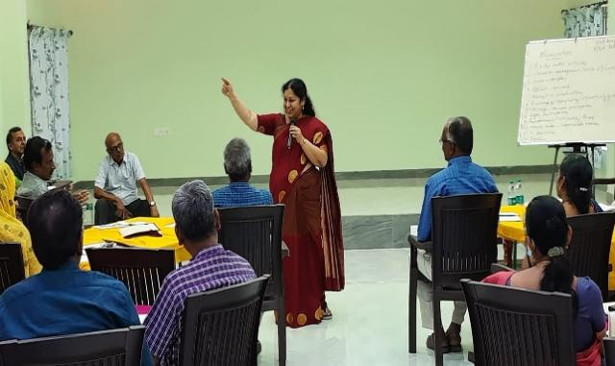
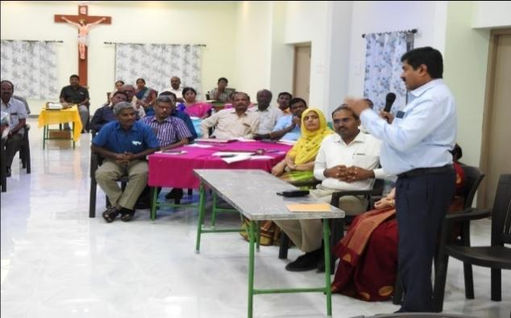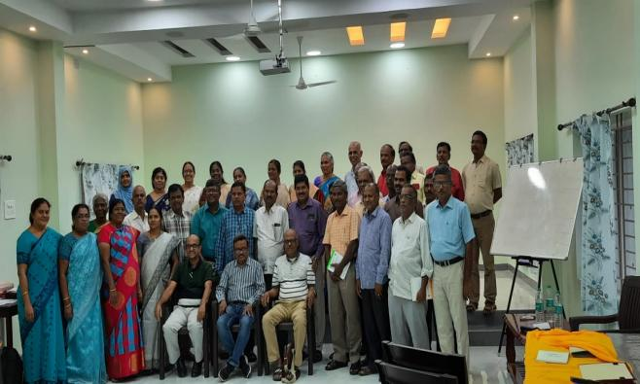
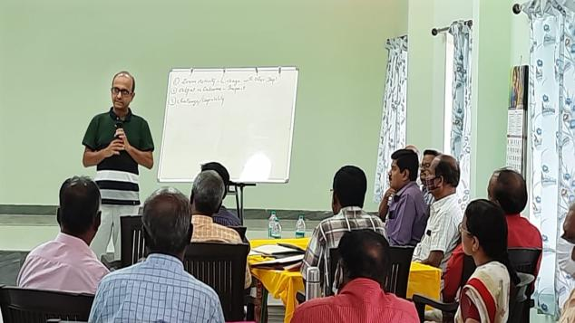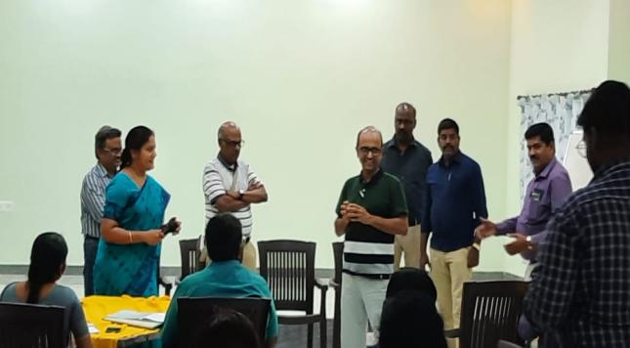
23.05.2022 to 25.05.2022-Attended Capacity Building Training at O’Nila Resort, Yelagiri Hills.
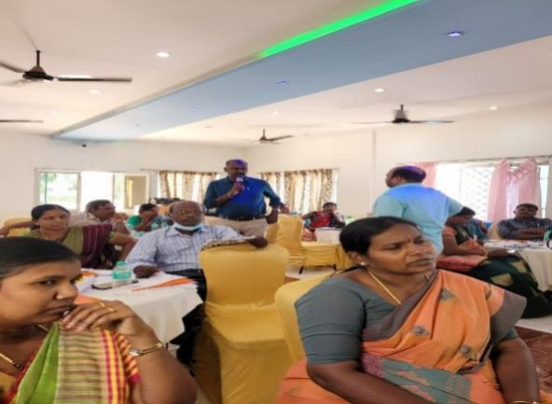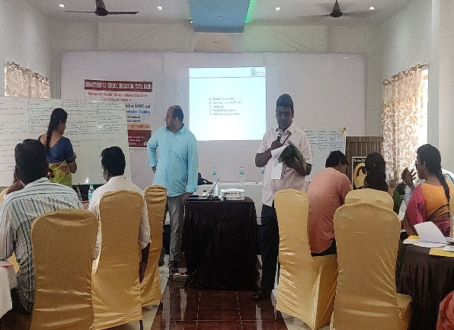
26.05.2022 : Coordinated TLM Preparation workshop (Tamil) for Ennum Eluthum programme
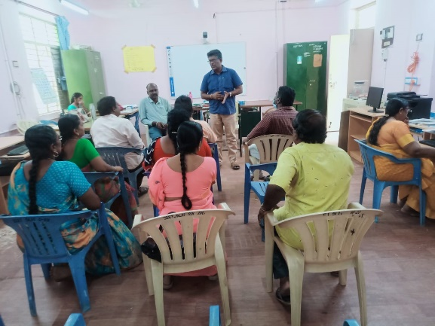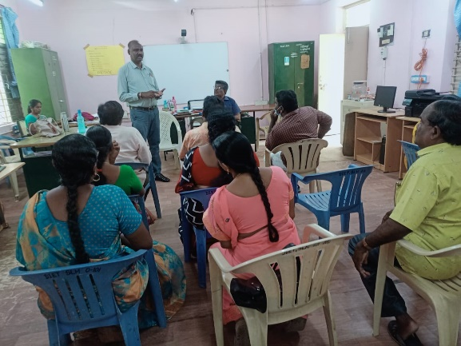
27.05.2022 : Coordinated TLM Preparation workshop (English) for Ennum Eluthum programme
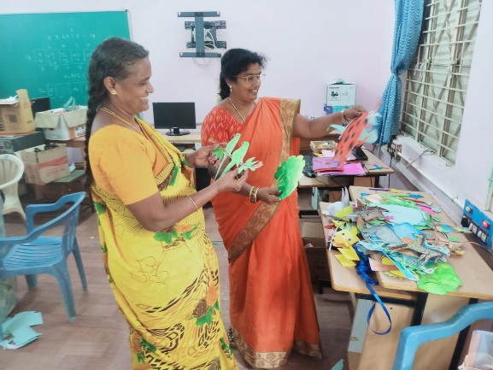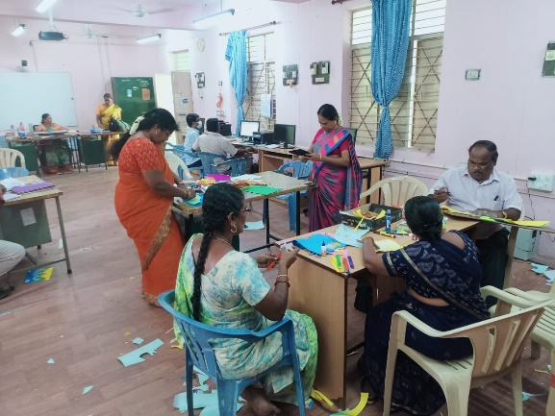

27.05.2022: Coordinated Innovative Teachers Award Programme with Rotary club at DIET, Salem.
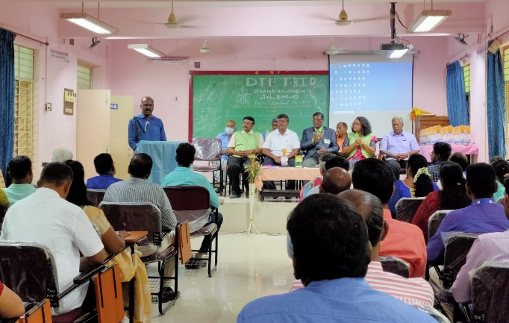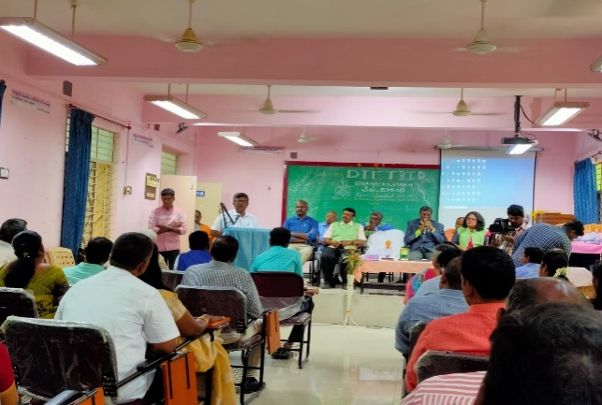
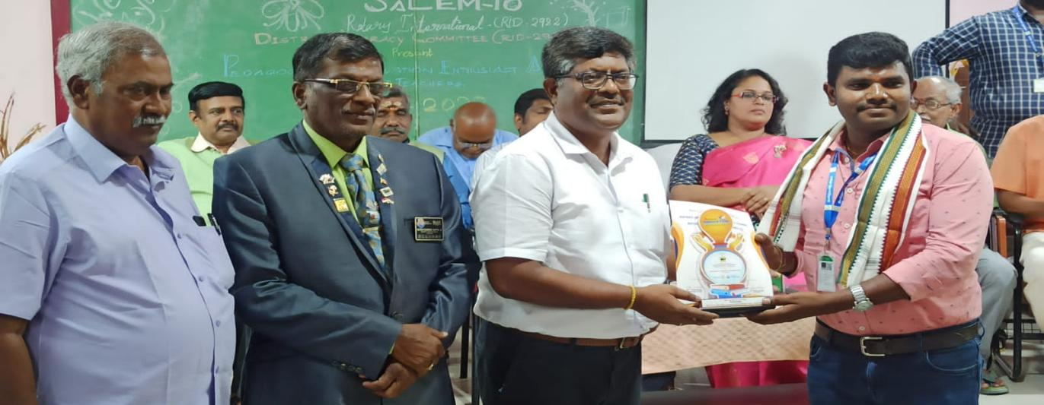
M.Mahalakshmi - Lecturer
- 2.5.2022 -Capacity Building Training Preparatory work was seen.
- 4.5.2022-Visited Capacity Building Training Center at Yercaud.
- 5.5.2022 - Action Research Budget Preparation work was seen.
- 6.5.2022 - Capacity Building Training Preparation work was seen.
- 8.5.2022-Training Arrangements were made at Yercaud for Capacity Building Training Programme.
- 9.5.2022 to 13.5.2022 –Coordinated and Organized the 5 Days Capacity Building Training for Principal’s and DD’s at St.Francis Home, Yercaud.
- 23.5.2022 to 25.5.2022 –Attended the Capacity Building Training Programme at Yelagri.
- 26.5.2022 to 28.05.2022 Attended Training programme on Preparatory work for Ennum Ezhthum Training at Pillar Hall, Madurai. Attended Ennum Ezhuthum Training at Pillar Hall, Madurai.
- 30.5.2022 –Attended TLM Preparation workshop at DIET for Math subject of”Ennum Ezhuthum” Training.
- 31.5.2022 –Organized Ennum Ezhuthum Training Programme Pre-Planning Meeting at CSI, TTI, Hasthampatti, Salem.
EDUCATIONAL TECHNOLOGY:(ET)
Dr G.Dhanammal – Senior Lecturer
- 4.5.2022 & 5.5.2022 - Bridge Course Material Topics Correction Work was seen.
- 6.5.2022- Attended DIET faculty members Interaction meeting with Dr Jaganathan VC of Periyar University, Salem and Attended Action Research Zonal Committee meeting for approval of Action Research Proposal.
- 9.5.2022 to 11.5.2022 - Bridge Course Material Module Preparation Workshop for 4thStd Coordinating Work was seen.
- 12.5.2022 to 17.5.2022 - Bridge Course Material Module Typing work was seen.
- 18.5.2022 - Life Map Preparation Work was seen.
- 19.5.2022 & 20.5.2022 - DIET – Reading Books and Life Map Preparation Work was seen.
- 23.5.2022 to 25.5.2022 –Attended the Self Professional Development (Capacity Building ) Training at Yelagri.
Dr V.Suganya - Lecturer
- 2.5.2022 -Action Research Proposal Preparatory Work was seen.
- 4.5.2022 & 5.5.2022 -Script Preparation work for Audio & Video Recording was seen.
- 9.5.2022 & 10.5.2022 -Content Enrichment PPT Preparatory work for 5thStd were done.
- 11.5.2022 -Explained about the DIET Studios activities to Periyar University faculty members.
- 12.5.2022 -Action Research Work was seen.
- 13.5.2022 - Studio Maintenance Work was seen.
- 16.5.2022 - Studio Stocks verified and entered in stock list.
- 17.5.2022 –“Birds Sound”-Quiz Preparatory work was seen.
- 19.5.2022 & 20.5.2022-Recorded Audio & Editing work was seen.
- 23.5.2022 & 25.5.2022 -Attended Self Professional Development (Capacity Building ) Training at Yelagri.
- 26.5.2022-April Month Newsletter preparation work was seen.
- 30.5.2022 & 31.5.2022-Attended Ennum Ezhuthum KRP’s Training at DIET.
M.Jayamani - Lecturer
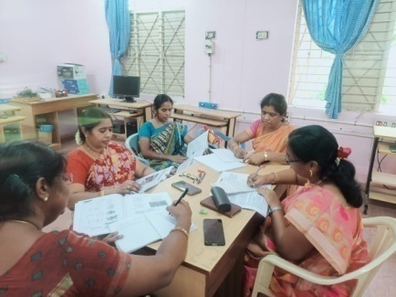
- 2.5.2022 -Bridge Course Module Preparation work was seen.
- 4.5.2022 - Attended Meeting on Vasakar Vattam at DIET library.
- 5.5.2022-Carried out Bridge Course Module Correction work.
- 6.5.2022 -Presented Action Research Proposal in ZARC Meeting.
- 9.5.2022 -Attended Bridge Course Workshop at DIET.
- 10.5.2022 to 11.5.2022 -Bridge Course Module preparation work was seen.
- 16.5.2022 to 20.5.2022 –Involved in Bridge Course module preparation workshop at SCERT, Chennai.
- 23.5.2022 to 25.5.2022 - Attended Capacity Building Training at Yelagri Hill.
- 26.5.2022 - Digital Content Support Preparation work was seen.
- 27.5.2022 -Attended Rotary Award Function for School Teachers at DIET.
DISTRICT RESOURCE UNIT:(DRU)
Dr P.SO.KESAVAN - Lecturer
- Acted as a reviewer for Class 1 to Class10 Learning Outcomes- Resources Preparation Training at Hotel Kanchi, Chennai.(SCERT)
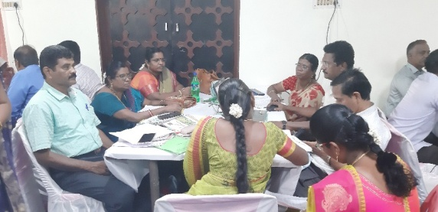
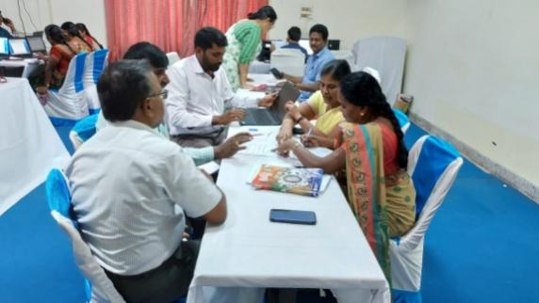

- Prepared Competency and Micro Competency for Class 6 to Class 8 Learning Outcomes.
- Attended- DIET faculty orientation programme at Yelagiri Hills from 26.05.2022 to 28.05.2022.

CURRICULUM MATERIAL DEVELOPMENT AND EVALUATION:(CMDE)
Dr R.NAGALAKSHMI - SeniorLecturer
- ZARC-Action Research proposal submitted on 6th May-2022.
- Attended Professional skill development-programme for Principals and DDs and acted as a facilitator at Yercaud from 9th to 13th May.
- Attended Professional skill development-programme for Principals and DDs and acted as a Facilitator at Yercaud from 19th to 28th May.
- Visited to Valapady Boys Higher Secondary School to ensure basic amenities for EE training programme on 31st May.
Dr B.Ananthi - Lecturer
1. Participated and Contributed in the Dictionary Review workshop at Asha Nivas, Chennai, organized by SCERT, Chennai from 04.05.2022 to 06.05.22.
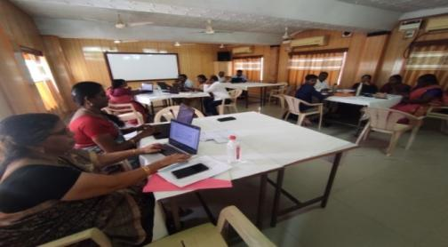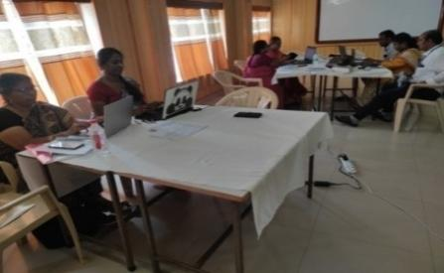
2. Participated in 'Professional Skill Development Training' for DIET faculty at O Nila Resort, Yelagiri, Vellore District, organized by SCERT, Chennai from23.05.2022 to 25.05.22 .
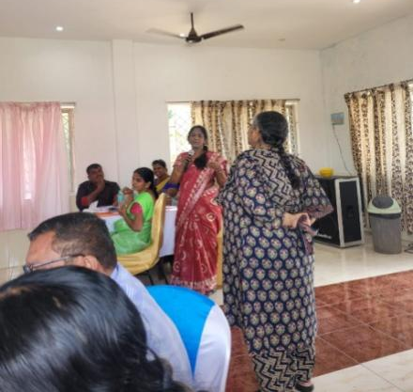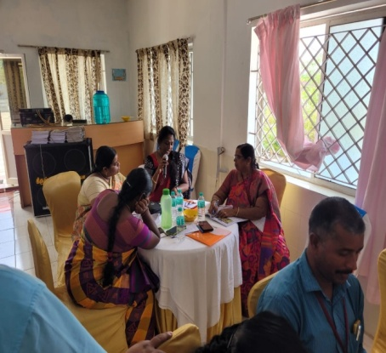

PLANNING AND MANAGEMENT: (P&M)
Dr K.Kannaki - Senior Lecturer
- 2.5.2022 to 4.5.2022 - Bridge Course Material Questions and Content Correction work was seen.
- 5.5.2022 - Bridge course material Topics correction work was seen.
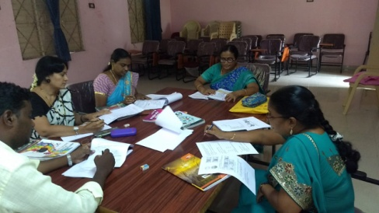
- 6.5.2022 – Submitted Action Research proposal before the ZARC meeting at DIET.
- 9.5.2022 to 11.5.2022 - BCM - Primary Math – preparation work for workshop was seen.
- 13.5.2022 - BCM - Module correction work was seen.
- 16.5.2022 & 17.5.2022 –Involved in DGE Confidential work at DSE at Chennai.
- 18.5.2022 to 20.5.2022 –Involved in Bridge Course material preparaton work at Kanchi Hotel, Chennai.
- 23.5.2022 to 25.5.2022 –Attended Capacity Building Training at Yealagri Hill.
- 26.5.2022 &27.5.2022 - Journal and Book reference made at DIET library for research work.
- 31.5.2022 –“Ennum Ezhuthum” programme work was seen.
B.Uthayakumar-Lecturer
- Attended “VasagarVattam” book review programme at DIET library by Dr.V.Suganya, Lecturer, book titled : Unaku Padika Theriyathu - Kamalayan
- 6.5.2022 - Action Research proposal submission before the ZARC at DIET.
- 31.5.2022 –“Ennum Ezhuthum” programme work was seen.
WORK EXPERIENCE: (WE)
Dr S.Vijayalakmi Shankar - Senior Lecturer
Date | ACTIVITIES
01.5.2022 | Conducted online programme through Google Meet-AASAN AVAI -24 Special programme-DIET & Rotary MOU -Resource Person : Mrs.M.Umamaheswari, Lecturer, DIET, Nammakkal dt . Topic: Mapping on Creative skills.
02.5.2022 | Attended Action resaerch proposal ZARC meeting with Principal, at DIET, Krishnagiri
04.5.2022 | Attended “VasagarVattam” book review programme at DIET library by Dr.V.Suganya, Lecturer, book titled : Unaku Padika Theriyathu - Kamalayan.
05.5.2022 | Preparation of AR Proposal work was seen.
06.5.2022 | Presented AR Proposal in ZARC & acted as committee member for Action research.
07.5.2022 | Consolidation of AR proposal & Research Project Proposal was seen.
08.5.2022 | Conducted online programme through Google Meet-AASAN AVAI -25 Special programme-DIET & Rotary MOU -Resource Person : Mr.Arumugam, B.T.Assistant, PUMS, Sankaridt . Topic: Google Read along -part I
15.5.2022 | Conducted online programme through Google Meet-AASAN AVAI -26 Special programme -DIET & Rotary MOU -Resource Person : Mr.Arumugam, B.T.Assistant, PUMS, Salem dt . Topic: Google Read along -part II
22.5.2022 | Conducted online programme through Google Meet-AASAN AVAI -27 Special programme-DIET & Rotary MOU -Resource Person : Dr Santhalakshmi, BT Assistant, dhasanaickenpatti, Salem dt. Topic: Teaching and Learning with Blended space
23.5.2022 | Action Research Review collection work was seen.
24.5.2022 | Preparation of Evaluation tool using Bamboozle App was seen.
25.5.2022 | Preparation of Evaluation tool using Bamboozle App was seen.
26.5.2022-28.5.2022 | Attended training on Professional Development Training for DIET Faculty at Yelagiri.
29.5.2022 | Conducted online programme through Google Meet-AASAN AVAI -27 Special programme-DIET & Rotary MOU -Resource Person : Dr Santhalakshmi, BT Assistant, dhasanaickenpatti, Salem Dt. Topic: Teaching and Learning with Blended space

Dr K.Kalaivanan - Lecturer
- 6.5.2022 -Attended Action Research ZARC Meeting at DIET.
- 7.5.2022 - Attended SMC மறு கட்டமைப்புகூட்டம், குறவர் காலனி, ஊ..ஒ. து. பள்ளி., கெங்கவள்ளி.
- 20.5.2022 - Visited “Illam Thedi Kalvi” Center at Gengavalli Block.
- 23.5.2022 & 24.5.2022 -Resource Persons Training : எண்ணும் எழுத்தும் மாநில அளவிளான பயிற்சி, பில்லர்ஹால், மதுரை.
- 30.5.2022 – Attended : எண்ணும் எழுத்தும் துணைக்கருவிகள் தயாரிப்பு பணிமனை.
DIET-Salem
K.Satchidanandam - Librarian
- Book database (data entry) for library books was done till date.
- Barcoding of library books are under progressing.
- Documented and listed out DIET Modules, Training reports, etc...For library reference purpose.
- Need based referral services to faculty members.
- Organized Weekly library Reader’s Club (Vasagar Vattam) programme at DIET library.
- Assisted and provided library resources to school teachers for preparing the Bridge Course Material Resources.
- Visited the Periyar University central library along with DIET Principal and met the VC of Periyar University, Salem.
- Initiated and Letter of Interest (LoI) handed over to the His Excellency, Vice Chancellor of Periyar University, Salem to utilize the University library resources remotely for DIET research activities.

Chief Editor : Dr M.SELVAM, PRINCIPAL
UTHAMACHOLAPURAM
SALEM-636010
Associate Editors : G.DHANAMMAL (SL)
Mrs .M.Jayamani (L)
Editor : Mrs.S.Selvi (L)
Phone : 7373003460
e-mail id :dietslm@gmail.com
Website : www.dietsalem.com

This Newsletter is Prepared and Published by ET Branch



